Task 02 — React API Project: Weather Application
Objective
o develop a React-based Weather Application that fetches real-time weather information from an external API and displays the data using reusable React components. The application includes city search, loading and error states, current weather information, and a 6-day forecast.
Technologies Used
- React 18
- Vite
- JavaScript
- Axios
- Open-Meteo API
- CSS
- GSAP
- Vercel

Screenshots

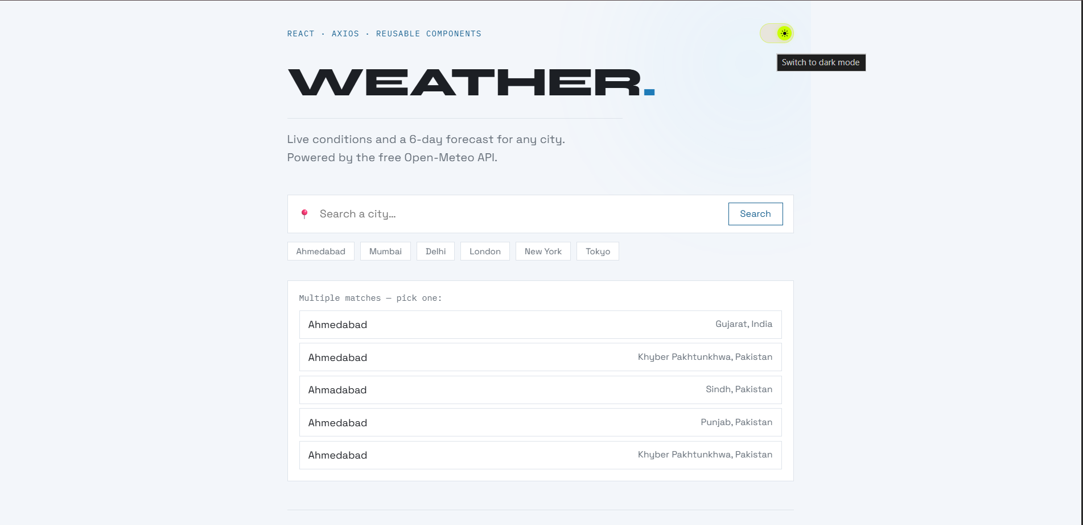
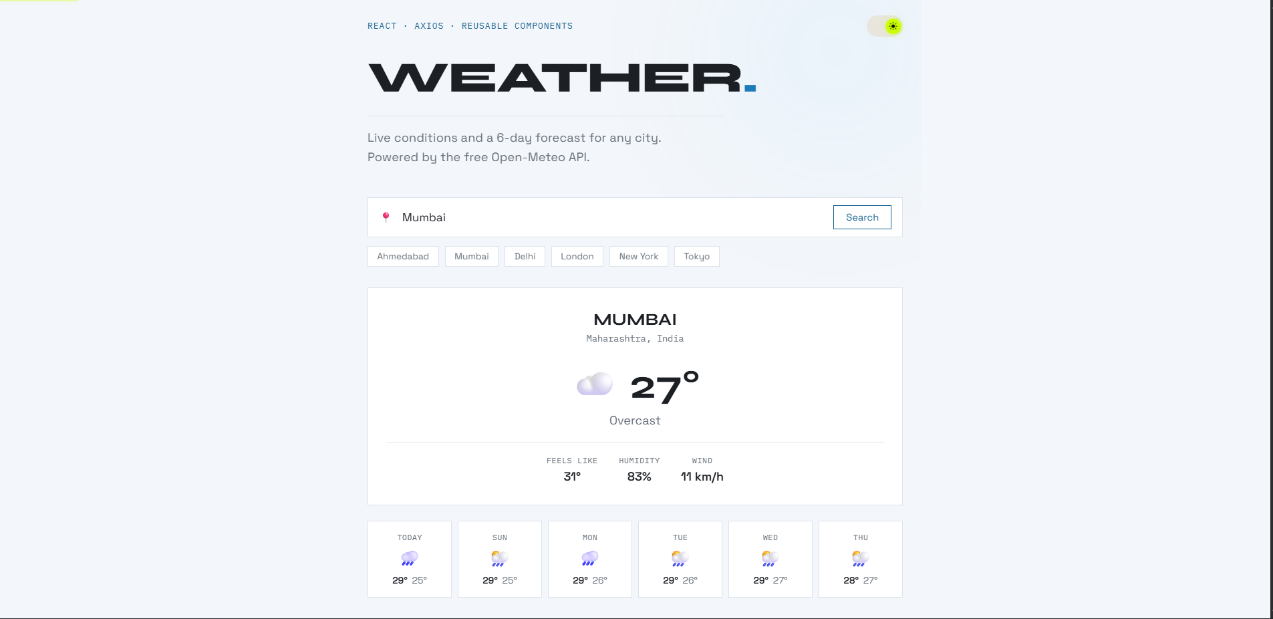
API Integration Using Axios
- Code Snippet — Axios API Service

import axios from 'axios'

const geoClient = axios.create({
baseURL: 'https://geocoding-api.open-meteo.com/v1',
timeout: 8000,
})

const weatherClient = axios.create({
baseURL: 'https://api.open-meteo.com/v1',
timeout: 8000,
})

export async function searchLocations(name) {
const response = await geoClient.get('/search', {
params: {
name,
count: 5,
language: 'en',
format: 'json',
},
})

return response.data.results ?? []
}

export async function getWeather(latitude, longitude) {
const response = await weatherClient.get('/forecast', {
params: {
latitude,
longitude,
current:
'temperature_2m,relative_humidity_2m,apparent_temperature,weather_code,wind_speed_10m,is_day',
daily:
'weather_code,temperature_2m_max,temperature_2m_min',
timezone: 'auto',
forecast_days: 6,
},
})

return response.data
}

Explanation:
Axios is used to communicate with the Open-Meteo API. Two Axios clients are configured: one for city geocoding and another for weather data. searchLocations() converts a city name into geographic coordinates, while getWeather() uses latitude and longitude to retrieve current weather conditions and a 6-day forecast. An 8-second timeout is also configured to prevent requests from hanging indefinitely.
Snippet 2 — React Data Fetching + Loading/Error States

async function runSearch(cityName) {
setStatus('loading')
setErrorMsg('')
setLocationOptions(null)

try {
const results = await searchLocations(cityName)

if (results.length === 0) {
setStatus('error')
setErrorMsg(
`No results for "${cityName}". Try a different spelling.`
)
return
}

if (results.length === 1) {
await loadWeatherFor(results[0])
} else {
setLocationOptions(results)
setStatus('idle')
}
} catch (err) {
setStatus('error')
setErrorMsg(describeError(err))
}
}

Explanation:
The runSearch() function manages the complete search flow. The application first changes the state to loading, performs the API request, and then handles different outcomes. If no city is found, an error message is displayed. If multiple locations are found, the user is given a choice. Network or server errors are caught using try...catch and displayed through the application's error state.

Snippet 3 — Reusable Weather Component
export default function WeatherCard({ location, current }) {
const { label, icon } =
describeWeatherCode(current.weather_code)

return (
<article className="weather-card">
<div className="weather-card__location">
<h2>{location.name}</h2>
<span>
{[location.admin1, location.country]
.filter(Boolean)
.join(', ')}
</span>
</div>

<div className="weather-card__main">
<span className="weather-card__icon">
{icon}
</span>

<span className="weather-card__temp">
{Math.round(current.temperature_2m)}°
</span>
</div>

<p>{label}</p>
</article>
)
}

Explanation:
WeatherCard is a reusable functional React component that receives weather information through props. It displays the selected location, current temperature, weather condition, and weather icon. Separating this functionality into its own component keeps the main App component organized and makes the weather display reusable.

Snippet 4 — 6. Search Component

export default function SearchBar({ onSearch, loading }) {
const [value, setValue] = useState('')

function handleSubmit(e) {
e.preventDefault()

const trimmed = value.trim()

if (trimmed) {
onSearch(trimmed)
}
}

return (
<div className="searchbar">
<form onSubmit={handleSubmit}>
<input
type="text"
placeholder="Search a city…"
value={value}
onChange={(e) => setValue(e.target.value)}
/>

<button type="submit" disabled={loading}>
{loading ? '…' : 'Search'}
</button>
</form>
</div>
)
}

Explanation:
The SearchBar component manages the city search input using React's useState hook. When the form is submitted, the entered city name is passed to the parent component through the onSearch callback prop. The search button is disabled while the API request is loading, providing feedback to the user.

Snippet 5 — Search Component

export default function ForecastList({ daily }) {
if (!daily?.time?.length) return null

return (
<div className="forecast">
{daily.time.map((date, i) => {
const { icon, label } =
describeWeatherCode(daily.weather_code[i])

return (
<div key={date} className="forecast__day">
<span>
{formatDay(date, i)}
</span>

<span title={label}>
{icon}
</span>

<span>
{Math.round(
daily.temperature_2m_max[i]
)}°

{Math.round(
daily.temperature_2m_min[i]
)}°
</span>
</div>
)
})}
</div>
)
}

Explanation:
The ForecastList component receives daily forecast data through props and dynamically creates a forecast item for each day using .map(). This makes the component reusable for different API responses and avoids manually creating individual forecast elements. Weather codes are converted into readable conditions using the application's weather-code utility.

Snippet 6 — API Documentation Notes
API Used
Open-Meteo API
The application uses two API endpoints.
Endpoint | Method | Purpose
/v1/search | GET | Converts a city name into location information
/v1/forecast | GET | Retrieves current weather and daily forecast
Geocoding API
https://geocoding-api.open-meteo.com/v1/search
Used to search for cities and obtain:
- City name
- Country
- Region
- Latitude
- Longitude
Weather API
https://api.open-meteo.com/v1/forecast
Used to retrieve:
- Current temperature
- Feels-like temperature
- Humidity
- Wind speed
- Weather code
- Daily maximum temperature
- Daily minimum temperature
Snippet 7 — Loading & Error UI
{status === 'loading' && (
<Loader label="Fetching weather…" />
)}

{status === 'error' && (
<ErrorMessage message={errorMsg}>
<button
onClick={() =>
runSearch(location?.name ?? DEFAULT_CITY)
}
>
Try again
</button>
</ErrorMessage>
)}

Explanation:
The application provides dedicated UI states for API loading and failures. While data is being fetched, the Loader component is displayed. If the API request fails or the city cannot be found, the ErrorMessage component displays an appropriate error message and provides a retry option.
Live Demo:
https://weatherrapi.vercel.app
GitHub Repository
https://github.com/Aditya00-git/task02

